**Executive Summary – Butterfly Robot Design**

**ELEC330 Assignment 2**

**Abstract**

This paper abridges the chief aspects of the design of a butterfly robot named Nectar Wings. Firstly, this paper introduces the key components of a simple robotic system, followed by the specification requirements for this project. Next, taking typical butterfly locomotion into account, the robot design and purpose are described. Finally, an overall analysis is given, highlighting future improvements and research developments that could be made based on this project idea.

**1 Introduction**

Robots are electronic, mobile machines that can execute tasks autonomously, semi-autonomously, or when manually operated by humans. All robots need a body or frame, actuators, sensors, a power supply, and a control system [1] to be classified as such. Furthermore, safety features must be implemented in the robot design to ensure the robot will not cause harm to living beings or the environment in which it will operate.

Biomimetic robots are a special type of robots designed to imitate real-life biological beings like humans or animals. This paper focuses on the design of a butterfly robot. The robot’s name, Nectar Wings, is based on its butterfly-like nature, as butterflies are winged insects that consume nectar as their primary food source. The overall aim is to develop a model of an autonomous, lightweight butterfly robot that can fly and uses a camera as sensor to autonomously navigate and collect environmental data (such as temperature, humidity, air quality, and pollen availability) in butterfly habitats.

The design objectives are:

* The robot should be able to take off, fly for 10 seconds, and land autonomously.
* The total weight of the robot should be less than 200g.
* The robot’s control system should enable the robot to take off, hover, and land safely.
* The robot should be able to deploy an emergency shutdown mechanism to avoid collision.

**2 Specification Requirements**

A typical butterfly insect has three main parts, being the head, thorax, and abdomen, along with wings, legs, and antennae [2]. Butterflies often fly in an erratic, fluttery manner, using “clapping motions”. [3] Their wing shape aids with flight, and different species have different wing shapes. [4] Based on the above information, Nectar Wings has the following key components to achieve the desired specifications:

* Dimensions: Fuselage length = 15 cm; Wingspan = 30 cm.
* Weight: 80 g.
* Wings and Holders: Wings are made from P31N fabric.
* Body and Frame: Made from carbon fibre.
* Motors and Motor Holders: Two GDW DS1906B motors, capable of enabling the wings to flap at a frequency of 5 Hz.
* Battery and Battery Holder: Two 200 mAh batteries, allowing for 10 minutes of flight.
* Control Unit and Holder: Allows for signal processing and flight command execution.
* Camera: 1080p camera at the robot ‘head’ to provide real-time visual data for path-planning and obstacle avoidance.
* Operating temperature: 0°C to 40°C.
* Humidity adaptation range: 30%-60%.

When designing the robot, we also considered environmental adaptability, data acquisition and processing, and safety.

**3 Robot Design and Model**

The robot was 3D modelled using SolidWorks and Fusion 360 to achieve a precise design and visualisation of each component. Fig.1. shows the design.

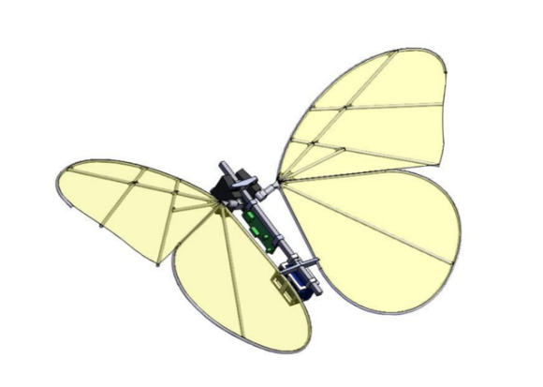*Fig.1. A 3D Model of Nectar Wings.*

The model can be divided into three assembly parts: Basebody, Leftwing, and Rightwing. Using the sw2urdf SolidWorks plug-in tool to configure the model’s joints, links, coordinates, and key points, a URDF file was generated. The robot model was imported into Gazebo for simulation. A Linux PC with ROS2 Jazzy was used to facilitate the simulation, and a Python launch file was used to launch the robot’s Gazebo simulation.

**4 Discussion and Reflections**

The "Nectar Wings" project effectively demonstrates how biomimetic design principles can enhance robotics, merging nature-inspired agility and advanced technological materials. Achieving critical milestones such as developing a structural model and integrating simulations into the Gazebo environment marks significant progress. This foundational work paves the way for the intricate journey from virtual models to tangible prototypes, emphasizing the importance of robust simulations and weight optimization in real-world applications.

The project's focus on lightweight design and agile movement, essential for flight stability, mirrors the efficient flapping mechanisms of butterfly wings, offering valuable insights for future physical prototypes. This approach not only improves performance but also contributes to the broader field of robotics by demonstrating practical applications in environments like environmental monitoring.

**Appendix**

**Group Member Contributions**

* Alvaro – Modeling work of motor, control systems, and other parts.
* Gideon – Writing the executive summary and report, organising all the notes, resources, and records in the group’s OneDrive folder.
* Junyang – Writing assignments report and Assisting Yifan in modeling.
* Yanzhang - The setup of ROS2 and simulation in Gazebo.
* Yifan - Modeling work of wings, wings holders and motor holders.
* Zijin - Writing assignments report and Assisting Yanzhang in simulation set.

**References**

[1] Tooling Ideas, “What Are The Key Components And Features Of A Robot,” 25 01 2024. [Online]. Available: https://toolingideas.com/what-are-the-key-components-and-features-of-a-robot/. [Accessed 20 10 2024].

[2] Cambridge Butterfly Conservatory, “All About Butterflies,” [Online]. Available: https://www.cambridgebutterfly.com/all-about-butterflies/. [Accessed 20 10 2024].

[3] K. Suzuki, M. Nakamura, M. Kouji, and M. Yoshino, "Revisiting the flight dynamics of take-off of a butterfly: experiments and CFD simulations for a cabbage white butterfly," *Biology Open*, vol. 11, no. 3, Mar. 2022, doi: 10.1242/bio.059136.

[4] McCoy, Shannon, "Butterfly wing shape variation among habitats and their phylogenetic relationships, June 2018" (2018). *Monteverde Institute: Tropical Ecology and Conservation*. 204.  
https://digitalcommons.usf.edu/tropical_ecology/204

## Code and Files

All code and files can be accessed via the Team Butterfly [GitHub](https://github.com/hebaal/ELEC330_Butterfly).

## Multimedia

Access the project team’s photos and videos via the QR Code below:



If unable to scan the QR Code, or if it does not function as expected, kindly access the group’s multimedia via the following link:

[ELEC330 - Group 5 Team Butterfly - Assignment 1 Multimedia](https://theuniversityofliverpool-my.sharepoint.com/:f:/g/personal/sggtladi_liverpool_ac_uk/Emyls53BpB1BipWK6Nu7o2gBj1f9CUfstNOQrP8Mobb4yw?e=sAkGxz)